# Templates in JMeter

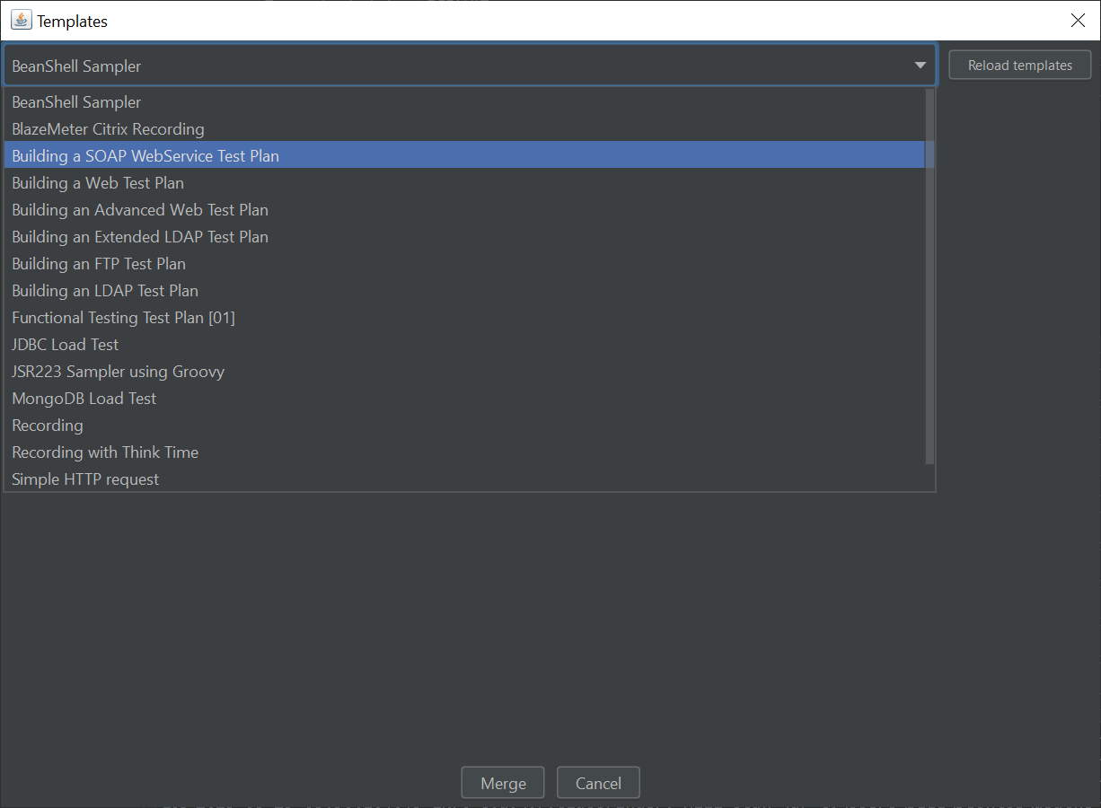

**JMeter Templates and Use Cases with Examples**

**• BeanShell Sampler**

* **What it is:** A scripting component that lets you write custom code in **BeanShell (Java-like scripting)**.
* **Use Case:** Add dynamic behavior to requests or manipulate data.
* **Example:**

java

CopyEdit

int x = 5;

int y = 10;

int sum = x + y;

log.info("Sum is: " + sum);

**• BlazeMeter Citrix Recording**

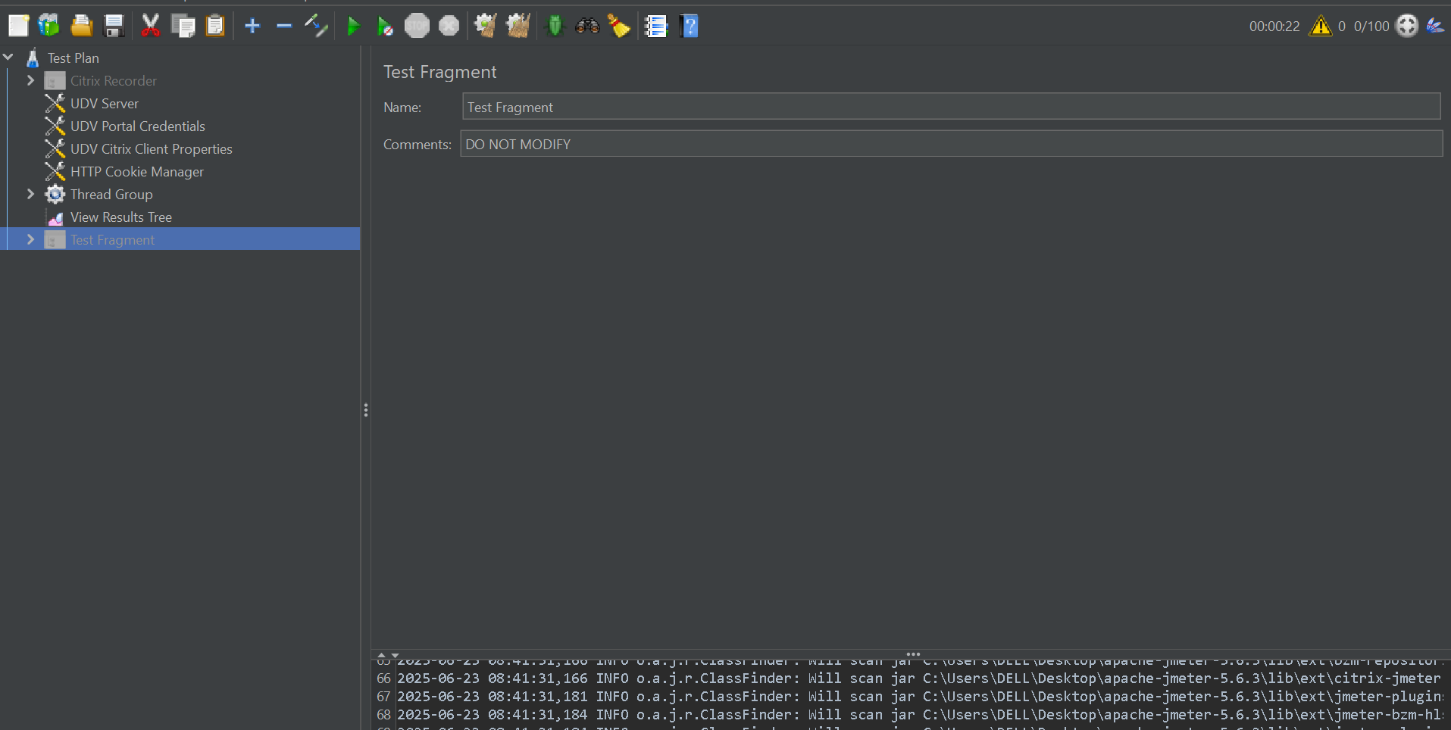

* **What it is:** A BlazeMeter-specific tool to simulate Citrix session recording.
* **Use Case:** Useful for Citrix app performance testing where standard HTTP recording doesn’t apply.
* **Example:** Record a Citrix user session and replay it in BlazeMeter for load testing.

**• Building a SOAP WebService Test Plan**

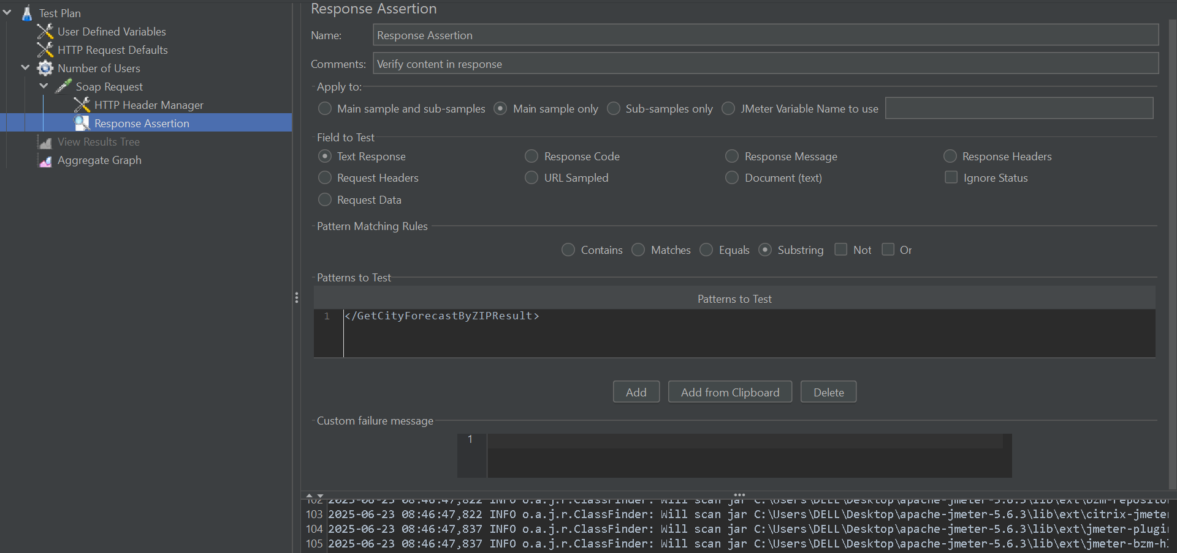

* **What it is:** Template for testing **SOAP-based** web services.
* **Use Case:** Validate the response of a SOAP request.
* **Example:**
  + Use **HTTP Request** with **POST method**
  + Add SOAP envelope in the **Body Data**
  + Set **Content-Type: text/xml**

**• Building a Web Test Plan**

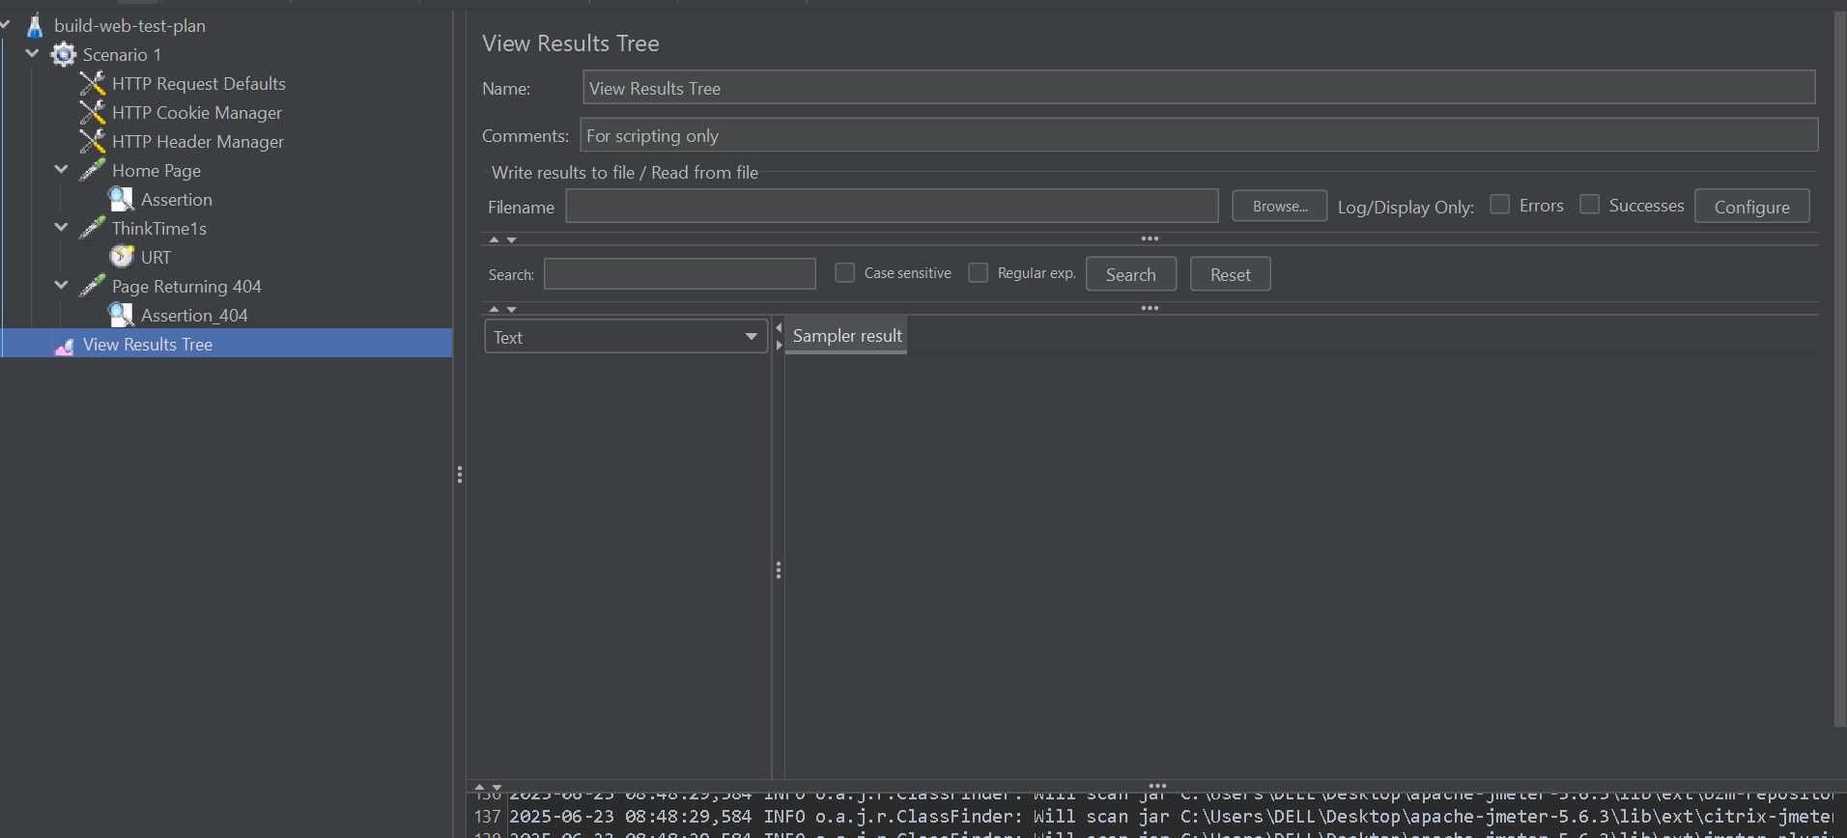

* **What it is:** Basic template to test websites.
* **Use Case:** Check performance of a simple website (HTML, CSS, JS).
* **Example:**
  + Thread Group → HTTP Request → "<https://example.com>"
  + View Results Tree → to verify page load time

**• Building an Advanced Web Test Plan**

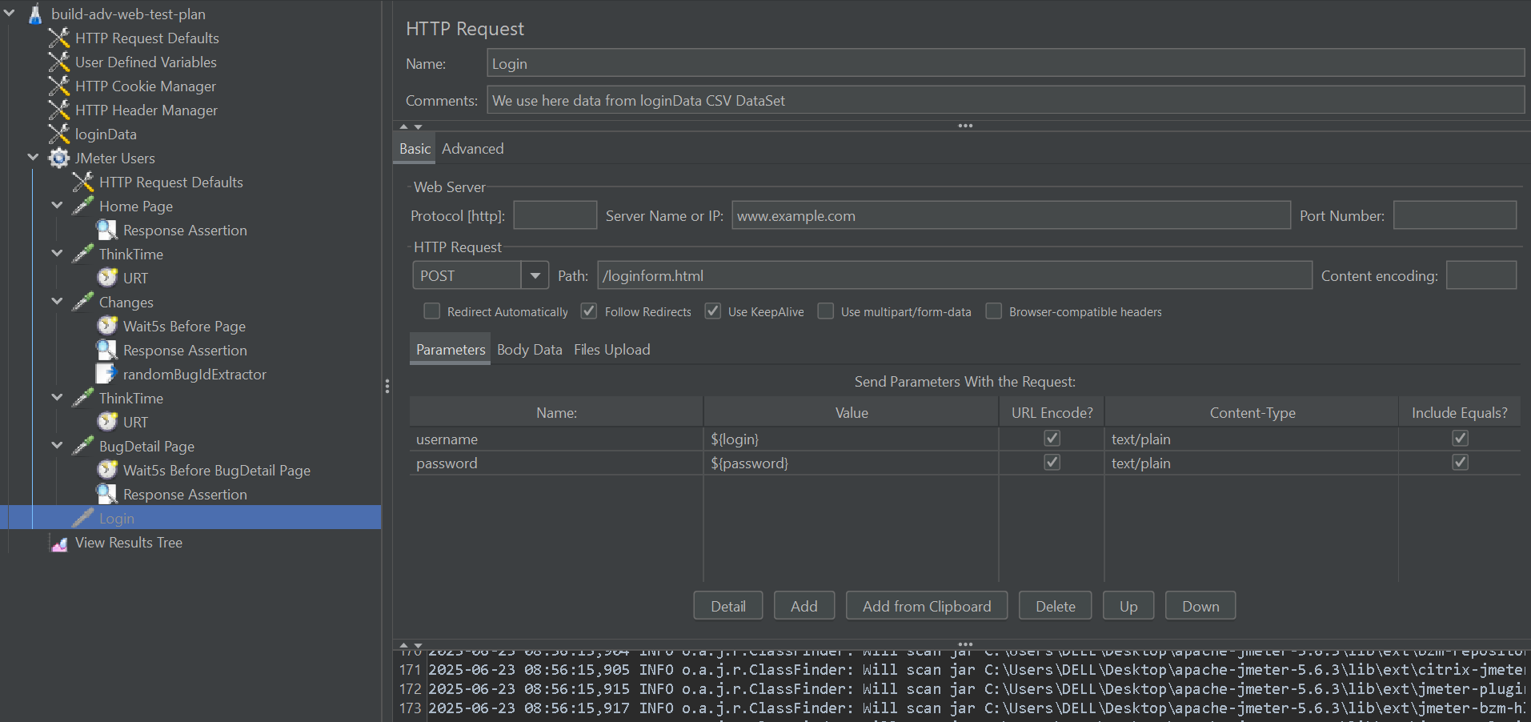

* **What it is:** Complex test scenario for web applications.
* **Use Case:** Add assertions, dynamic variables, and timers.
* **Example:**
  + Use **Regular Expression Extractor** to get session IDs
  + Add **Think Time** using **Constant Timer**

**• Building an Extended LDAP Test Plan**

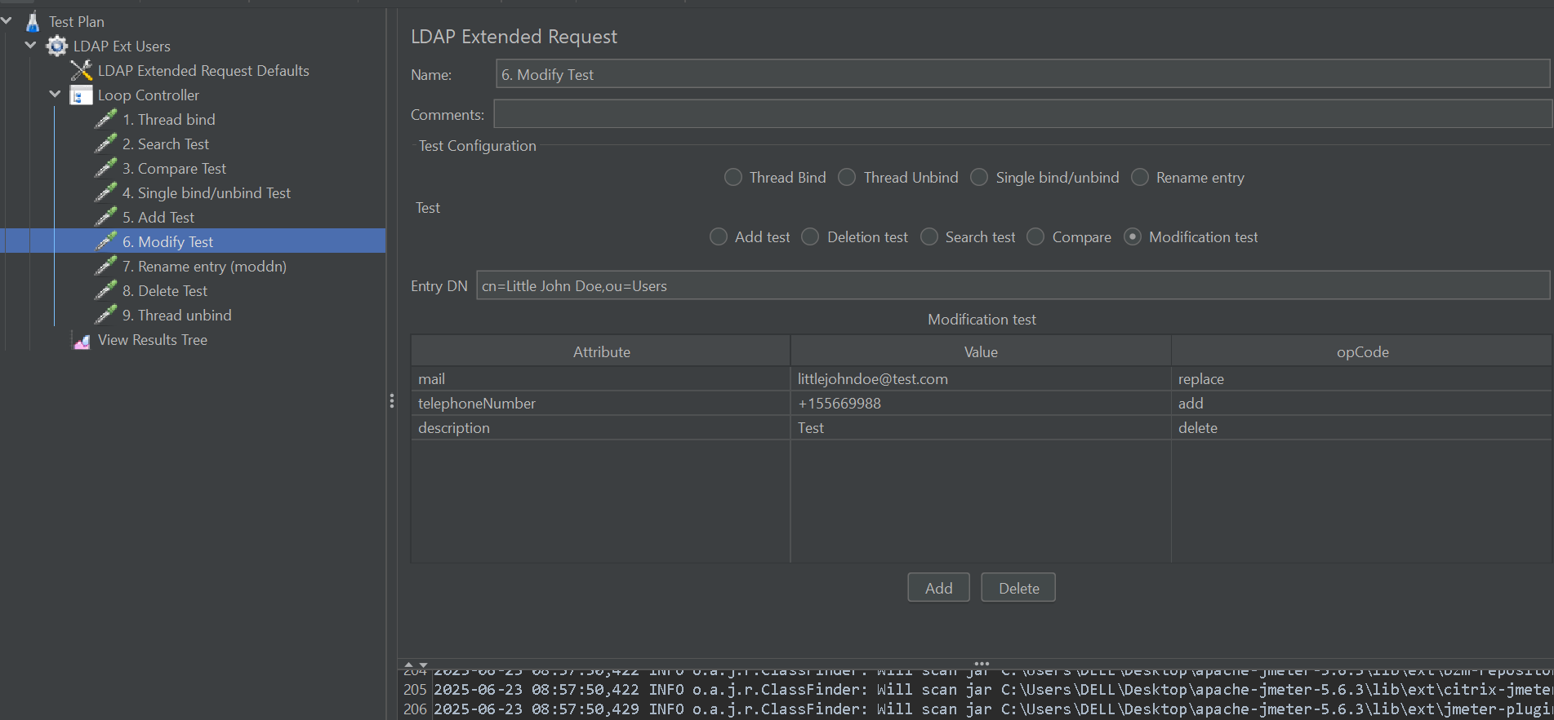

* **What it is:** Template for complex LDAP server authentication and directory search.
* **Use Case:** Test organizational directory structure or access policies.
* **Example:**
  + Use **LDAP Request Sampler** to search entries like:
    - Base DN: dc=example,dc=com
    - Search Filter: (uid=jsmith)

**• Building an FTP Test Plan**

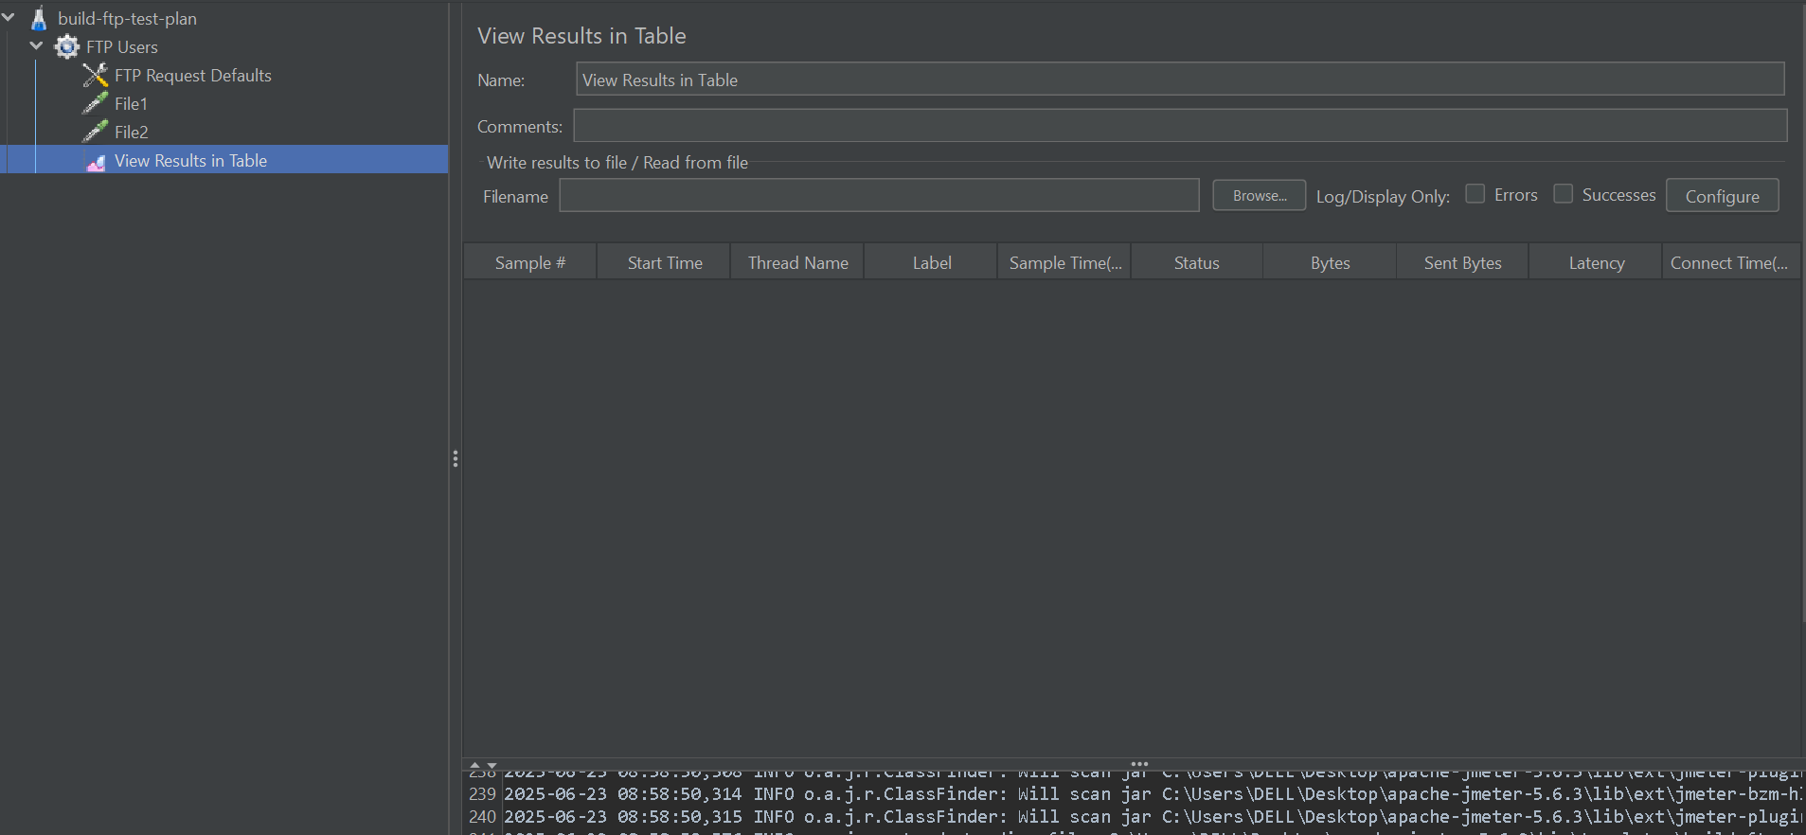

* **What it is:** Template to test **FTP file uploads/downloads**.
* **Use Case:** Validate if the FTP server is accessible and responsive.
* **Example:**
  + **FTP Request Sampler** → Upload or download a test file

**• Building an LDAP Test Plan**

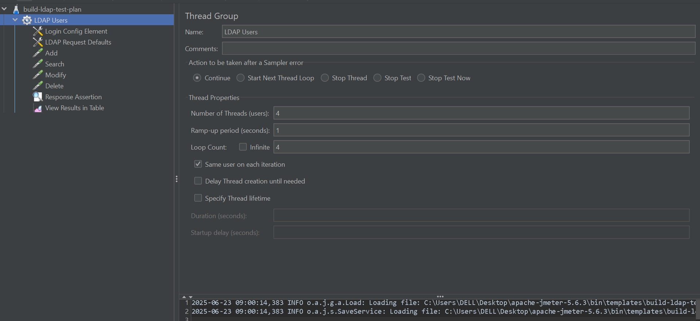

* **What it is:** A simpler version of the Extended LDAP test.
* **Use Case:** Basic **user authentication** and **data retrieval**.
* **Example:** Login to LDAP server and check if credentials are valid

**• Functional Testing Test Plan [01]**

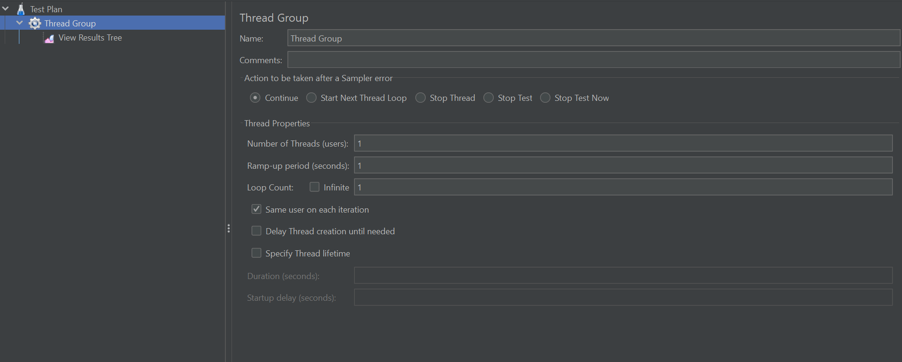

* **What it is:** Used for **asserting application behavior**, not just load.
* **Use Case:** Check if correct responses and status codes are returned.
* **Example:**
  + Add **Response Assertion**: Text Contains "Login successful"

**• JDBC Load Test**

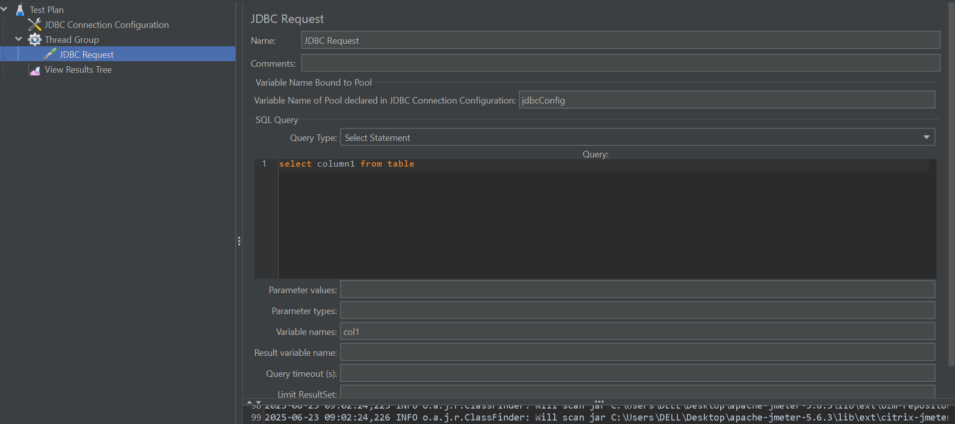

* **What it is:** Template for **database performance testing** using JDBC.
* **Use Case:** Run **SQL queries** against a database.
* **Example:**
  + Configure JDBC Connection Config with DB URL, driver
  + Add SQL: SELECT * FROM users WHERE id=101

**• JSR223 Sampler using Groovy**

* **What it is:** Advanced scripting sampler using **Groovy**, faster than BeanShell.
* **Use Case:** Handle dynamic test logic or process data.
* **Example:**

groovy

CopyEdit

def currentTime = System.currentTimeMillis()

log.info("Current Time: " + currentTime)

**• MongoDB Load Test**

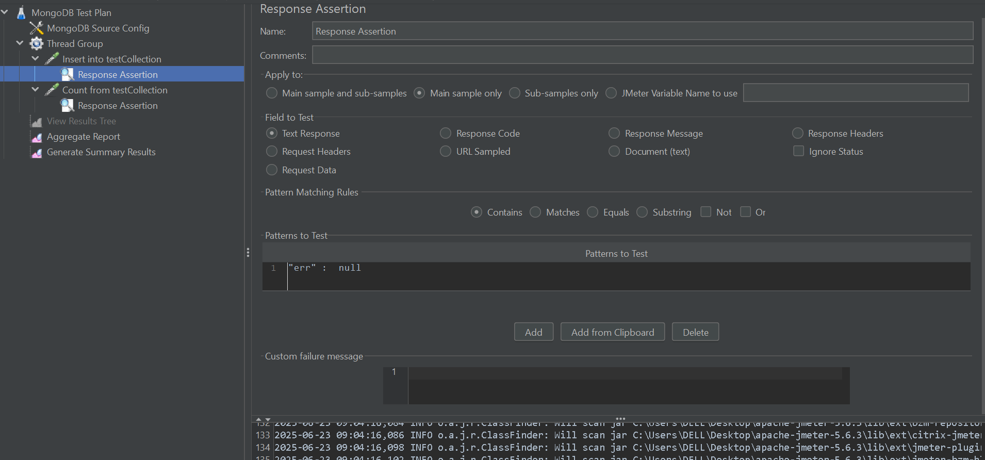

* **What it is:** Custom test plan to test **MongoDB performance**.
* **Use Case:** Run queries and updates on MongoDB.
* **Example:**
  + Use **MongoDB Source Config** and **MongoScript** to run:

javascript

CopyEdit

db.users.find({age: {$gt: 30}})

**• Recording**

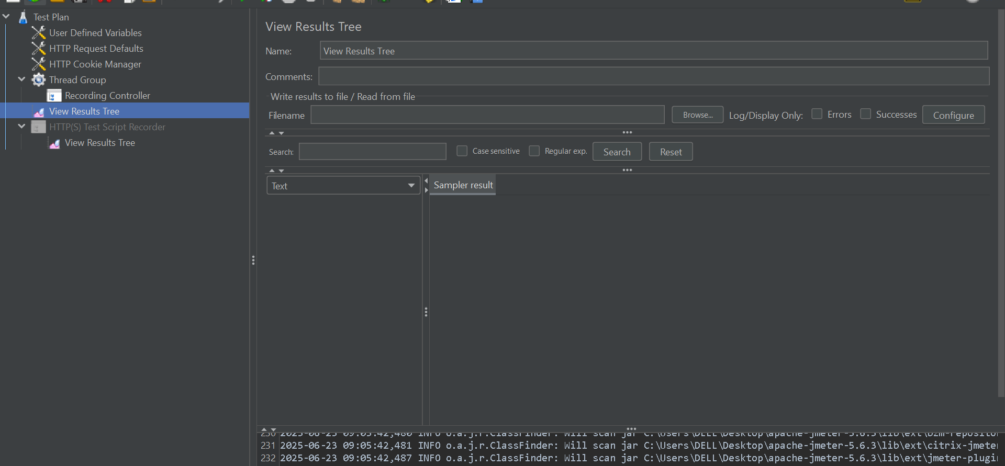

* **What it is:** A blank template with **HTTP(S) Test Script Recorder**.
* **Use Case:** Capture browser-based activity.
* **Example:** Use a proxy with JMeter and browser to record a login flow

**• Recording with Think Time**

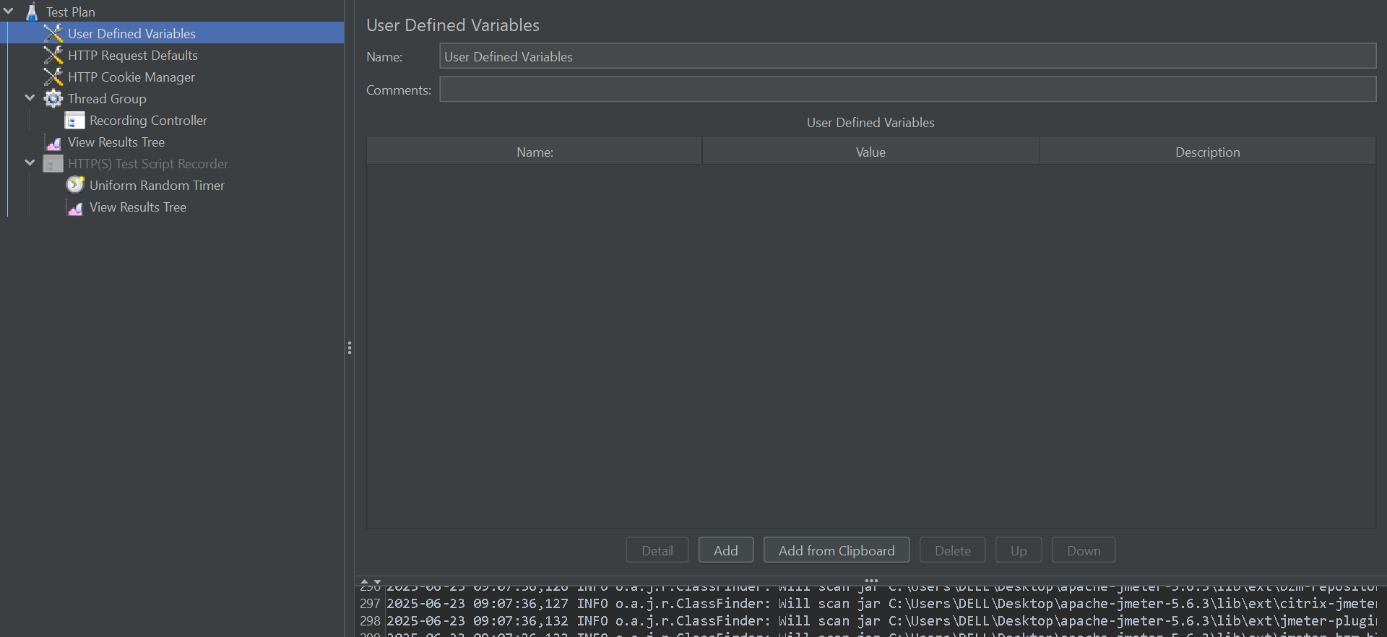

* **What it is:** Like above, but **preserves user pause time** between actions.
* **Use Case:** Simulate real-user interaction delays.
* **Example:** Login → Wait 5s → Click profile → Wait 3s → Logout

**• Simple HTTP Request**

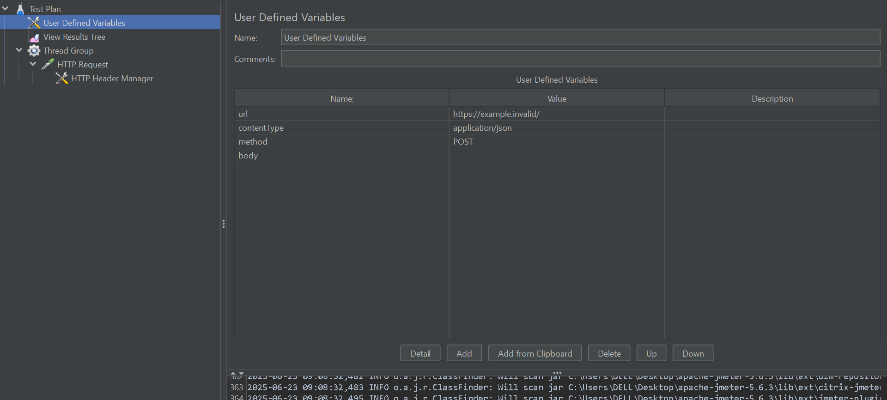

* **What it is:** Basic HTTP GET/POST test plan.
* **Use Case:** Ping an API or website.
* **Example:**
  + Thread Group → HTTP Request →  
    URL: https://api.example.com/status  
    Method: GET